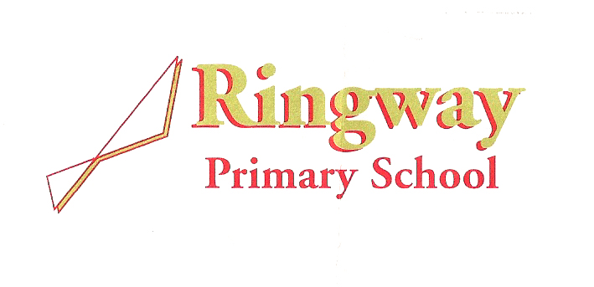
Rossett Avenue
Cornishway
Wythenshawe
Manchester
M22 0WW
Telephone: 0161 437 1899
Email: admin@ringway.manchester.sch.uk
Headteacher: Mr Daniel Taylor

Welcome from the Chair of Governors
Dear prospective applicant,
Thank you for your interest in joining Ringway Primary School. Ringway is a busy, ambitious and inclusive two-form entry school at the heart of Wythenshawe, with around 405 pupils. We are proud to be a ‘good’ school (Ofsted, January 2023), but we are not standing still. Our community is diverse and changing: around 30% of our pupils speak English as an additional language, more than half are entitled to free school meals, and a growing number have special educational needs. This makes Ringway a rewarding place to work. Every adult has the opportunity, and the responsibility, to help children feel safe, included and ready to succeed.

Our values - Love, Laugh, Learn - shape the experience we want every child and colleague to have. Love means knowing our children, building trusting relationships and treating people with care and respect. Laugh reflects the warmth, joy and sense of belonging that bring our school community together. Learn is our commitment to high expectations, curiosity and continual improvement. Our vision, Think Big: Fly High, is the ambition behind those values: we want children to see what is possible, believe in themselves and leave Ringway ready for their next step.

We are looking for people who will bring these words to life: colleagues who are kind and dependable, ambitious for every pupil, willing to learn, and ready to contribute beyond their own role. You will need to combine high standards with patience, teamwork and a genuine understanding of the community we serve. In return, you will join a school where your contribution is visible and where the work can make a lasting difference.

Working at Ringway is purposeful, fast-moving and highly relational. We will expect you to play your part, speak up, support others and keep children at the centre of your decisions. In return, we can offer:
- A friendly, committed and hard-working team that supports one another;
- Children who are happy to be at school, want to learn and value adults who believe in them;
- The chance to make a tangible difference for children and families in our community;
- A supportive appraisal culture for teaching and support staff, with access to training and the opportunity to shape your professional development;
- A practical commitment to workload, health and wellbeing;
- Flexible working options, where these are compatible with the role and pupils’ needs, including PPA from home, wellbeing tokens providing paid time off, part-time working and sabbatical opportunities;
- A Governing Body committed to strong oversight, support and sustained school improvement; and
- Access to the Cycle to Work scheme, employee discounts and an Employee Assistance Programme.

What our families say
Our families see the care, commitment and high standards that colleagues bring to Ringway:

I think all the staff who have looked after my children have been amazing. From nursery through to Year 6. I think they go above and beyond for each individual child in their care.

I think this is a brilliant school and staff are lovely.

The quality of teaching and the parent communication are both brilliant.

What our pupils say
Most importantly, our pupils describe a school where they are challenged, heard and welcomed, the clearest expression of Love, Laugh, Learn and Think Big: Fly High:

They work us very hard but that’s a good thing; they push us.

No matter who you are, you are always listened to and welcomed.

If you share our ambition and believe you can help our children think big and fly high, I strongly encourage you to visit before applying. A tour will give you the best sense of our pupils, our team and the energy of Ringway. Please contact the school office to arrange an appointment—we would be pleased to meet you, answer your questions and show you what makes our school special.

Yours sincerely,
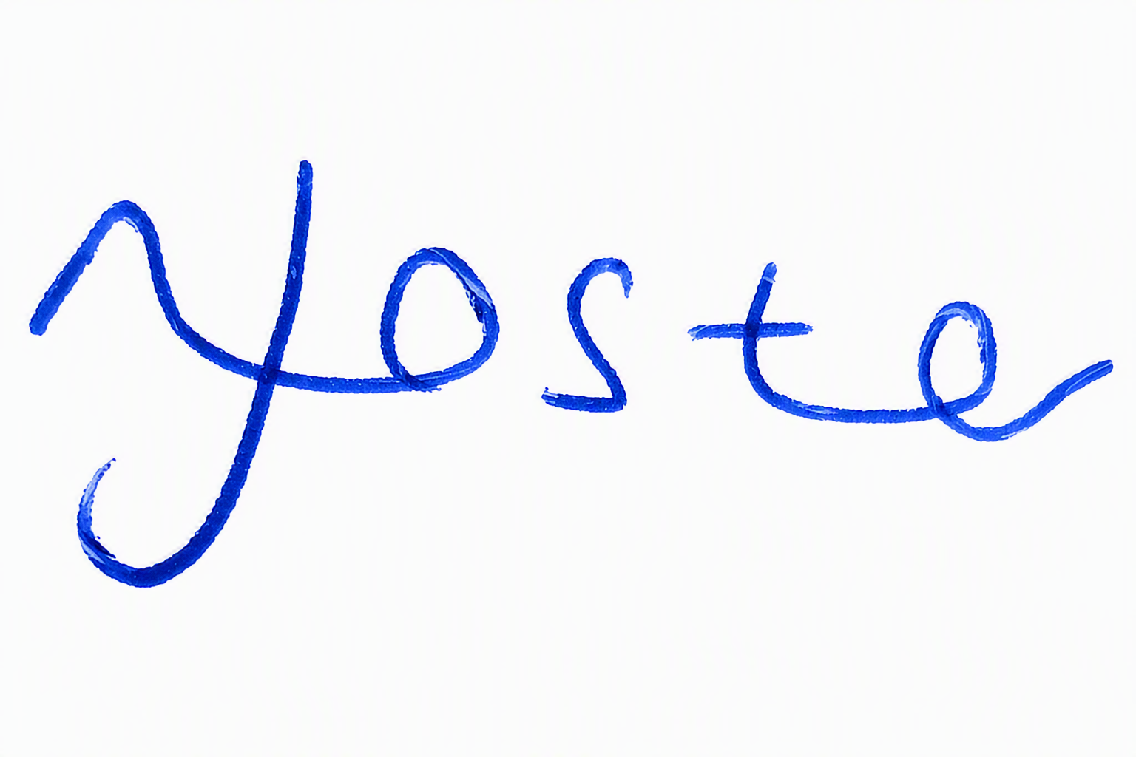
Nicola Foster
Chair of Governors
Ringway Primary School

