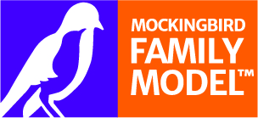
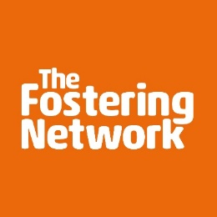

Are you looking for a new fostering challenge in Manchester?

Do you feel you have the skills and knowledge to share with other fostering families?

Are you interested in being a part of the first extended family model for our cared for children and foster families within the local authority?

If you answered YES to any of the above, Mockingbird could be for you.

Role – Mockingbird Hub Home Carer for our South Manchester Constellation
Salary - £601 weekly payment

Mockingbird at Manchester
Here at Manchester, we are looking to recruit an experienced foster carer/foster family into the role of the ‘Hub Carer’ who would play a significant role within the implementation of our programme, Mockingbird.
Within Mockingbird, there is one Hub Carer/Hub Family, who supports 6 to 10 other foster carers, who are called Satellite Carers. Altogether, the group is called a constellation.
‘The Hub Carer(s)’ role is to support other foster families directly and indirectly, support with planned and unplanned sleepovers for children within the constellation and importantly embedding a family approach by organising group activities and events for the foster families.
Mockingbird focuses on supporting fostering families and children in daily life, and is not to be used as a crisis model. For some of our cared for children, they have not had the advantage of being part of an extended family, which is what the model aims to achieve.

About the Mockingbird programme

Mockingbird is a global award-winning programme led by The Fostering Network in the UK. It delivers sustainable foster care. It is an evidence-based model structured around the support and relationships an extended family provides.
The model nurtures the relationships between children, young people and foster families supporting them to build a resilient and caring community.
Led by a hub home carer and liaison worker (supervising social worker), the constellation community offers vital peer support and guidance alongside social activities and sleepovers to strengthen relationships and permanence. The Mockingbird programme is an alternative method of delivering foster care which centres on the idea of an extended network of family support. It empowers families to support each other and overcome problems before they escalate and offers children a more positive experience of care. To find out about the national programme visit www.thefosteringnetwork.org.uk/mockingbird

MOCKINGBIRD HUB HOME CARER CRITERIA
The Hub home carers act as the glue that unites the foster families in each group together, into a community. This is a full-time role for an experienced foster carer(s) who has completed training in line with the national standards. To qualify for the hub home carer role, you will need to:

- Have 2 empty beds for planned and unplanned sleepovers for the children and young people within the constellation depending on the needs of the child/young person (please note, this does not mean 2 spare bedrooms and we are flexible with the arrangement, so please get in touch for further information)

- Be ready to support and mentor the other foster carers within the group, you will be taking on a leadership role where other carers will rely on you for advice

- Be a creative person who has ideas around hosting regular social events for the families within their constellation

- Support foster families where needed such as helping children maintaining their ties with their birth family

- Be confident in attending training and encouraging others within the constellation to learn about relevant topics

- A hub home carer needs to be confident, energetic, patient, empathetic and ready to coach other foster families whilst working closely with their liaison worker

- An attractive and competitive financial package will be offered to the successful hub home carer

TO APPLY To find out more about the Mockingbird programme and the role of a hub home carer within Manchester, please email your name and details to Courtney.adshead@manchester.gov.uk
