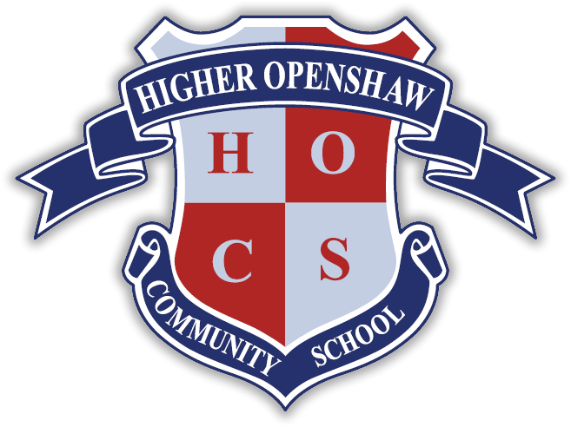

Job Advert TA3 - Higher Openshaw Community School

Employer: Higher Openshaw Community School / Manchester City Council
Location: Higher Openshaw Community School, Saunton Road, Higher Openshaw, Manchester, M11 1AJ
Grade: TA Level 3, Grade 4 (Scale Point 7-11)
Working Pattern: Full Time, Term Time
Working Hours: 35 per week
Contract Type: Permanent
Closing date: 16/10/26
Job Type: Education School based, School Support Staff
Interview Date: To be Confirmed (Shortlisting – week of 19/10/26)

The Governors of Higher Openshaw Community School are looking to recruit an individual to join our dynamic teaching support team. The role involves pastoral and academic support to the young people in our school, often supporting a particular class teacher. The role will initially be within our EYFS / KS1 team but could be expanded to whole school support in the future.
You will need to;
- Possess English and Maths GCSE (Minimum Level C / Grade 5) or equivalent qualifications
- Have good communication and interpersonal skills
- Be able to demonstrate you have the ability to use your own initiative
- Be an excellent team player
- Be passionate about helping young people make progress and succeed
- Be resilient with effective behaviour management strategies when required
The successful candidates will:
- Have experience of working with or caring for primary age children.
- Have a basic knowledge of first aid, child welfare and hygiene.
- Have the ability to relate well to both children and adults.
- Be able to work constructively as part of a larger team, understanding roles and responsibilities and your own position within these.
We can offer;
• support and guidance
• an opportunity to work with friendly and motivated staff
Start Time 8.30am - 4.00pm, 39 weeks per year. (30 mins lunch)
Higher Openshaw Community School is committed to safeguarding and promoting the welfare of children. Applicants must be prepared to undergo stringent child protection screening including checks with past employers and a DBS disclosure is required.
We are an Equal Opportunities Employer and we positively welcome applications from all candidates regardless of age, disability, gender reassignment, marriage and civil partnership, pregnancy and maternity, race, religion or belief, sex and sexual orientation.
Closing Date: Friday 16th October 2026
Please download and read the attached information before proceeding with your application.
Completed applications can be emailed directly to the school: admin@higher-openshaw.manchester.sch.uk

This post is subject to Enhanced Disclosure Procedures and a Children’s Barred List check.

Higher Openshaw Community School and the School Governing Body are committed to safeguarding and promoting the welfare of children.

