Manchester City Council
Role Profile
Advanced Practitioner Mockingbird Co-ordinator, Grade 8
Children’s Social Care, Children’s Services Directorate
Reports to: Fostering Team manager
Job Family: Children and Families - Fostering
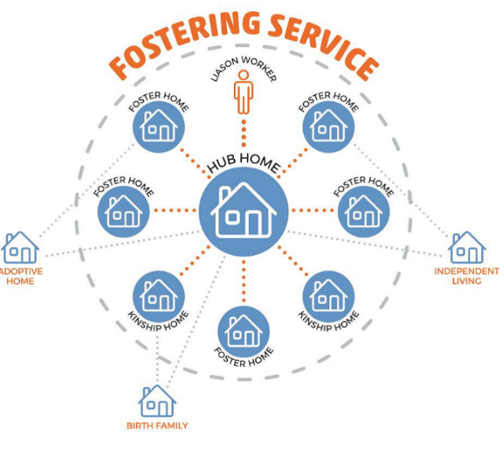
Key Role Descriptors:
Manchester has partnered with The Fostering Network to deliver the Mockingbird Family Model. This is an innovative extended family model that aims to improve the stability of fostering placements and strengthen the relationships between carers, children and young people, fostering services and birth families. Our goal is especially to ensure that sibling attachments and relationships are supported to thrive.
The Mockingbird Liaison Worker will have a lead role in the recruitment of the third and following Mockingbird constellations, and the development of Mockingbird constellations alongside supporting the established constellations. They will be well organised and have the skills to put the Mockingbird Family Model into practice with fidelity.
The Liaison Worker will work with key partners to develop a shared understanding of and commitment to the Mockingbird Model. The Constellation Liaison Worker will have a lead responsibility to recruit Foster Carers to the constellation, and work with families in the constellation to create an extended family community for children and young people. They will provide effective communication about the offer and work of the Mockingbird Constellation and ensure that the Fostering and social work teams work effectively with the constellation and Hub Carer.
The postholder will report to the Fostering Manager and will support the wider work of the Fostering Service.
Mockingbird Key role accountabilities:
To support the stability of foster families and children using a holistic approach. Mockingbird is a key part of the fostering service’s stability offer to our foster carers and children. Your role as project co-ordinator is to ensure you understand and promote the needs of the constellation and hub carers and children, with the desired outcome of increased stability and less movement through the foster care system for our children. To work in an innovative way ensuring the project focuses on stability not crisis. Children cannot move into the constellation in crisis.
To be effective in communication and providing highlight reports to senior management. You will be expected to attend regular stability steering meetings with senior management, in which you will be responsible for providing concise feedback to leaders across children’s services about the progress and development of Mockingbird within Manchester.
To promote Mockingbird throughout the wider children’s services, linking with district social care teams, cared for children, IRO’s, fostering teams and foster carers, with the purpose of recruiting hub and constellation carers, and identifying children to be supported by the constellations.
To liaise with The Fostering Network to ensure the Mockingbird programme remains within fidelity and meets the specific guidelines. You will work closely with a designated coach from the Fostering Network who will offer guidance and support in developing an implementing the programme.
Networking with GMCA Mockingbird partners to create strong working relationships. All 10 GMCA LA’s have funding for Mockingbird programmes, and close working relationships are vital to support best practice.
Working in partnership with the fostering recruitment and assessment team to promote Mockingbird within recruitment and retention realms. As the post holder, you will report to the manager of the Recruitment and Assessment team and will need to be active in supporting external recruitment of possible Mockingbird hub carers. Also, in identifying new applicants who could be part of Mockingbird constellations.
Implementing the launch of constellation 4. We currently have 3 Mockingbird constellations in Manchester, with funding for 1 more. You will do this alongside developing and supporting our 3 established Mockingbird constellations.
Additional oversight and planning of the satellite families within the constellations to allow for effective permanency planning for children and young people. This includes attendance planning meetings and stability meetings for those in the constellation, alongside the hub home carers. To work independently, including chairing meetings where appropriate.
Conduct data returns with hub homes through use of systems such as Excel to share with stakeholders. The role holder will need to be competent in using Excel for data analysis. Take lead on liaising with departments such as finance and contracts and commissioning.
Be an active member throughout monthly constellation meetings and social events and activities. This can involve weekend and evening hours. Each constellation at least 1 social event per month with the children, as the role holder, it is your responsibility to ensure there is a fostering service presence at these.
To work in an innovative way ensuring the project focuses on stability not crisis. Children cannot move into the constellation in crisis.
To support foster families within constellations with their development, wellbeing and to promote the training offer.
Engage in monthly supervision with the Fostering Team Manager to update on families and development of the project.
As an AP in the fostering service, you will support the management of our duty system one week in every 7. This is alongside the Mockingbird role. You will receive support from managers in this aspect of your role.
A desirable responsibility would be to have your practice educator qualification and be able to support a student within the fostering service or be willing to work towards this following being appointed to the role.

Advanced Practitioner Role Portfolio:
As an Advanced Practitioner in the fostering service, you will bring your knowledge and skills from social work to contribute to the best possible practice of our fostering service. You will be passionate about nurturing and developing others and will have relevant experience of supporting others in your team. You will be motivated to develop the Mockingbird project within Manchester, whilst also taking on responsibilities of an AP within a team of assessing and supervising social workers. You will have a good understanding of what ‘good practice’ looks like and will be able to support others to develop this knowledge alongside your team manager.
Primary purpose and scope
To provide effective and high quality professional social work to children and their families in accordance with legislation, national, regional and local statutory guidance, policies and procedures with the outcome of improving the lives of children in Manchester city council. The post holder will work with stakeholders to effectively manage and plan for present and future risk situations of service users by assessing the needs of individual children drawing on their experiences and voices, and ensuring links to current practice, research and theoretical bases to inform care planning.
Key accountabilities
Understand the role of the child and family and child development
The post holder will be responsible for building effective professional relationships with children and families that enables full participation in assessment, and care planning based upon best evidence which addresses risk in all its forms. The post holder will take account of child development theories and new learning to inform their practice and shape their assessment and analysis of risk and care planning, taking into account that each child is unique within developmental norms. The post holder will assess the influence and impact of cultural and social factors on the child’s development including key factors such as parenting styles, and the child’s resilience/uncertainty to change and loss.
Understand factors that impact children including abuse and neglect
The post holder will identify the impact that social and environmental factors have on parents and carers ability to promote good outcomes for children accessing help for them via other services and adult interventions to promote the outcome of improving the child’s outcomes. This will include early help, domestic violence, mental health services and coordinating as part of social work intervention to reduce concerning adult behaviours that could increase risk to children. The post holder will exchange information with partner agencies as part of their responsibilities to safeguard and promote the safety of children. Taking into account the long term and acute aspects of child abuse in all its forms. The post holder will lead investigations of allegations of significant harm listening and challenging appropriately the views of others to assess and analyse risk. As part of this the post holder will coordinate and lead a coordinated risk management plan to protect children from significant harm.
Undertake effective direct work with children and families
The post holder will demonstrate the ability to develop strong interpersonal skills to engage and motivate children and their families in a variety of circumstances such as child protection enquiries and assessment, to enable change. The post holder will draw on theoretical evidence-based interventions and research to inform their practice and interactions with children and families in all stages of their journey and interaction with social care from early help transition to adult services, independence and adoption.
Undertake child and family assessment demonstrating effective analysis, decisionmaking, planning and review
The post holder will have the ability to communicate clearly and sensitively with children of all ages and abilities drawing on a range of agreed evidence-based communication methods to enable them to share their wishes and feelings. The post holder will be able to demonstrate effective care planning utilising skills to critically evaluate risks alongside evident strengths to make effective decisions and ensure solution focused approaches to problem solving that draws on utilising finite resources to maximum effect. This will include working with the voluntary and community sector. The post holder will be able to undertake clear jargon free case recordings, written reports which evidence clear analysis and rationale for decisions made.
Understand the law and the family justice system undertaking ongoing research
Understand the role of a Social Work within the family justice system and how relevant regulation and statutory guidance relates to the law and carry out all duties with due regard to confidentiality and data protection regulations and legislation. Keep records up to date in compliance with Manchester City Council recording policy and procedures. Develop opportunities to share and reflect on decisions made on an ongoing basis, including seeking advice from other professionals and agencies.
Demonstrate professional ethics
Ensure that all children and adults are valued regardless of age, gender orientation and disability.
Deliver performance management and service improvement
The post holder will support the leadership of the team and service through the provision of advice and supervision to colleagues, contributing to the ongoing development of staff, students and trainees. .Take responsibility under the direction of the team manager for the support and supervision of a student social worker on placement, acting as practice teacher if appropriately trained. Will lead and co-work cases and specific areas of work that are complex and sensitive as part of supporting and developing colleagues’ development within the team and as part of this induction new staff. Ensure that the regular use of quality assurance processes in the development of frontline practice as part of supporting the improvement of practice and development of a high-quality service to children and families.
Deputise for the team manager in their absence and or when directed to do so and assist the team manager in ensuring health and safety of staff and individuals and the safety of equipment and operations within the team, in accordance with health and safety legislation. Personal commitment to continuous self-development and service improvement. Through personal example, open commitment and clear action, ensure diversity is positively valued, resulting in equal access and treatment in employment, service delivery and communications.
Where the role holder is disabled, every effort will be made to supply all necessary aids, adaptations or equipment to allow them to carry out all the duties of the role. If, however, a certain task proves to be unachievable, job redesign will be given full consideration.

Key Behaviours, Skills and Technical Requirement
Our Manchester Behaviours
• We are proud and passionate about Manchester
• We take time to listen and understand
• We ‘own it’ and we’re not afraid to try new things
• We work together and trust each other
• We show that we value our differences and treat people fairly
General Skills
Communication skills: Is able to effectively transfer key and complex information to all levels of staff, adapting the style of communication as necessary and ensuring that this information is understood. Ability to communicate equally, appropriately and effectively with the widest range of individuals and groups across all sectors and levels of society. This includes being able to tailor your communication to different workers and managers and to develop effective relationships.
Planning and Organising: Demonstrate the ability to apply analytical and logical thinking into gathering and analysing information, designing and testing solutions to problems and formulating plans. Ability to maintain focus and objectivity under various conditions and skill in managing and maintaining a multi-priority workload, progressing various ideas and plans concurrently.
Problem Solving and Decision Making: Ability to react to immediate problems of a highly complex nature with associated risk factors and deliver pragmatic solutions sometimes under extreme pressure. This includes recognising when to seek direction from management where appropriate.
Creative Skills: Uses creative ability to find solutions and whilst considering policy and procedure is also confident in adopting (and justifying) novel or nonstandard approaches. Willing to offer new ideas and ways of working to strengthen the ASYE offer in Manchester.
ICT Skills: Ability to use IT systems to retrieve, record and update information and willingness to learn to use new systems to support the data and tracking of Mockingbird fidelity and progress.
People Management: Ability to exert positive influence over the performance of others, promoting others’ self-esteem, inspiring trust and fostering confidence in others’ ability to achieve high standards, thereby enhancing a performance orientated culture which supports the delivery of high-quality services to the community.

