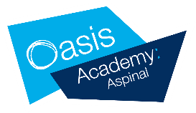

|  |  |  |
| --- | --- | --- |
| POST: |  | Lunchtime Organiser |
|  |  |  |
| LOCATION: |  | Oasis Academy Aspinal |
| WORKING PATTERN: |  | 7.5 hours a week a week term time only. |
| DISCLOSURE LEVEL: |  | Enhanced |

Oasis Academy Aspinal is a happy place where learning is fun and exciting. All staff are supportive and we are an inclusive place to work.

For an informal discussion about the role, please contact the school e-mail admin@oasisaspinal.org  
  
The post is fixed term for 18 months, to start on the 1st September 2024. The interview date is Tuesday 23rd July.

We are committed to safeguarding and promoting the welfare of children and young people. We expect all staff to share this commitment and to undergo appropriate checks, including enhanced DBS checks.  
  
This post is covered by Part 7 of the Immigration Act (2016) and therefore the ability to speak fluent spoken English is an essential requirement for this role.

Oasis is committed to making a difference to the lives of the communities it works in, and as such you must show a willingness to demonstrate commitment to the values and behaviours, which flow from the Oasis ethos. We are committed to safeguarding and promoting the welfare of children and young people. We expect all staff to share this commitment and to undergo appropriate checks, including enhanced DBS checks.