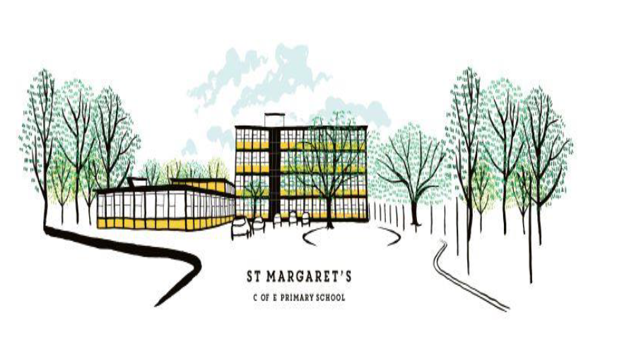

# JOB DESCRIPTION

|  |  |
| --- | --- |
| **POSITION** | Nursery TA2 position- 2-year-old provision |
| **GRADE** | Grade 3 point 4-6, All Year round FTE £24,404 - £25,183 (term time only) |
| **HOURS** | Part time- 20 hours currently at £12.65 per hour |
| **REPORTS TO** | Nursery Year Group Leader |

## KEY PURPOSE OF THE JOB

To take responsibility for the education and welfare of pupils in the 2-year-old provision in accordance with the current School Teachers’ Pay and Conditions document, having due regard to the requirements of the National Curriculum, EYFS framework and school policies.

## MAIN ACTIVITIES

1. To take responsibility for implementing appropriate learning programmes for all 2-year-old provision, within the framework of national and school policies.
2. To maintain assessment records and report on pupils’ progress to senior staff and parents in accordance with school policy.
3. To have knowledge and understanding of what constitutes quality in EYFS educational provision, the characteristics of effective Early Years settings, and strategies for raising pupils’ achievement

# PRINCIPAL ACCOUNTABILITIES

1. To contribute to successful team work across the 2-year-old provision
2. To be a key worker for a group of pupils.
3. To support school’s planned curriculum intent, implementation and impact by delivering a broad, balanced, relevant and stimulating range of provision and activities for 2-year-olds.
4. To teach daily carpet sessions to a group of pupils
5. To support pupils on a 1:1 and group basis in the continuous provision.
6. To support school’s ethos of inclusion by respecting and celebrating cultural diversity and providing equality of opportunity.
7. To ensure a close match between the learning experiences offered and the individual needs of pupils, giving each child an opportunity to achieve to the highest possible standard.
8. To provide children with opportunities to manage their own learning and become independent learners as well as to learn co-operatively.
9. To create a secure, happy and stimulating nursery environment, maintaining the highest standards of organization.
10. To foster each child’s positive mental health and establish relationships which are based on mutual respect.
11. To maintain a high standard of displays within the provision.
12. To arrange for resources, equipment and materials to be available in such a way that they are properly cared for, easily accessible and encourage the children to become more responsible for their own learning.
13. To assess pupils’ progress, maintain records and provide written reports to parents in accordance with school policies.
14. To communicate and consult with parents and outside agencies, as necessary, about pupils’ progress and attainment.
15. To liaise with staff both school based and from other external bodies as required.
16. To work collaboratively with other members of the nursery team.
17. To engage in continuous professional development through staff meetings and INSET activities.
18. Tend to the intimate care of pupils.

# KEY ORGANISATIONAL OBJECTIVES

The post holder will contribute to the school’s objectives in service delivery by:

* Ensuring compliance with school and national safeguarding procedures and policies.
* Enactment of health and safety requirements and initiatives as directed.
* Ensuring compliance with data protection legislation.
* At all times operating within the school’s agreed policies and approaches.
* Commitment and contribution to improving standards for pupils as appropriate.
* Contributing to the maintenance of a caring and stimulating environment for pupils.

# CONDITIONS OF SERVICE

(Governed by the national agreement on Teachers’ Pay and Conditions, supplemented by local conditions as agreed by the Governing Body).

Because of the nature of the post, candidates are not entitled to withhold information regarding convictions by virtue of the Rehabilitation of Offenders Act 1974 (Exemptions) Order 1975 as amended. Candidates are required to give details of any convictions on their application form and are expected to disclose such information at the appointed interview.

Because this post allows substantial access to children, candidates are required to comply procedures in relation to police checks.

# EQUAL OPPORTUNITY

The post holder will be expected to carry out all duties in the context of, and in compliance with, St Margaret’s CE Primary School’s Equal Opportunities Policy.

Date of issue: ………………….… Signed post-holder ……………………..…………………………………………

Signed Headteacher ………………………………………..………………