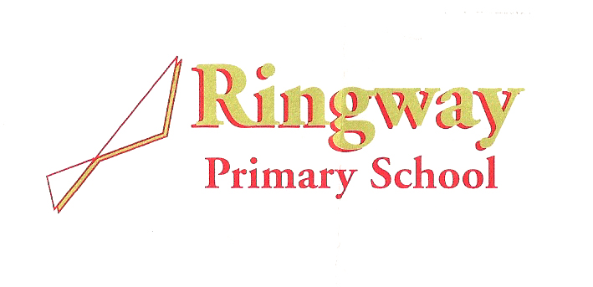Rossett Avenue  
Cornishway

Wythenshawe

Manchester  
M22 0WW

Telephone: 0161 437 1899

Email: [admin@ringway.manchester.sch.uk](mailto:admin@ringway.manchester.sch.uk)

Headteacher: Mr Daniel Taylor

**Welcome from the Headteacher**

Dear prospective applicant,

Thank you for your interest in our School. Ringway is a ‘good’ *(Ofsted January 2023)*, larger than average two-form entry school with around 460 pupils on roll in Wythenshawe, Manchester. As well as our school having grown in recent years, the make-up of our students has also changed and we currently have around 30% of pupils with EAL, over half of our children who are entitled to free school meals and a growing number of children with special educational needs. We pride ourselves on creating a warm, welcoming atmosphere and are looking for people who really care about our children to become part of our Ringway family.

As a school, we have all agreed on the values: ***Love, Laugh, Learn***. We also have a new vision statement of **‘*Think Big: Fly High*’**. We will be working hard as a team to embed these values and we would like any team member joining to help instill these values and reinforce them in the language we use and in how we act and what we do.

As a school we can offer you:

* A dynamic, friendly and hard-working team;
* A commitment to reducing workload;
* A supportive appraisal process and culture (including for support staff);
* A focus on promoting positive health and wellbeing;
* A school which fully embraces flexible working (including PPA from home, wellbeing tokens (giving paid time off), remote working and CPD, part time and sabbatical opportunities;
* Access to training and the chance shape your own professional development;
* Children who are well behaved and happy being at school;
* A recently reformed Governing Body who is committed to school improvement;
* The chance to really make a difference to the lives of children who need it most; and
* Access to Cycle to work, discounts and an Employee Assistance Programmes.

But what do the parents say about Ringway?

*I think all the staff who have looked after my children have been amazing. From nursery through to Year 6. I think they go above and beyond for each individual child in their care.*

*I think this is a brilliant school and staff are lovely.*

*The quality of teaching and the parent communication are both brilliant.*

And most importantly…..what do the children say about Ringway!?

*They work us very hard but that’s a good thing; they push us.*

*No matter who you are, you are always listened to and welcomed.*

I would welcome and strongly encourage prospective applicants to come and visit our school for a tour in advance of applying. You can do so by contacting the school office and making an appointment.

Yours sincerely,

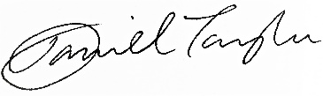

Mr D Taylor

Headteacher

Ringway Primary School