Values Behaviours
Value | Not good enough for Irk Valley | Getting it Right | The perfect fit for Irk Valley
  How we address and solve problems | Does not contribute ideas to help solve problems. | Contributes ideas when solutions are needed. | Behaves and acts in a way that shows a belief that there are solutions to problems. Has a solution-focused approach.
 | Focuses on blame rather than solutions. | Considers changes to own behaviour first when solving problems – What can I do? | Always asks questions to find out more about a situation, before acting and seeks out other views
 | Leaves problems for others to solve. | Is creative when solving problems. Is prepared to try things out. | Is proactive in noticing, addressing and solving problems. Finds the opportunity in challenges.
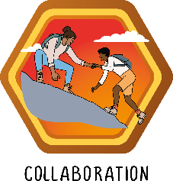  The way we work with others and importance we give to shared goals | Doesn’t accept responsibility for their own mistakes, tries to blame someone or something else for missed deadlines, poor performance or conflicts | Can be relied upon to meet deadlines, do what they have agreed to do to a high standard | Always has sight of the bigger picture- working together leads towards better outcomes for our pupils
 | Not willing to be flexible with ways of working. | Following all policies and agreed ways of working that help teams work well | Works flexibly and in ways that are not always preferable for them for the sake of the team.
 | Not making time for the team: for collaborative conversations; not meeting deadlines and agreed timescales | Knows what is going on at school – reads and acts on This Week, weekly email, INSET messages and Annual overview | Giving feedback and improving on other’s work. Engaging in conversation about shared work in order to improve the quality of it.
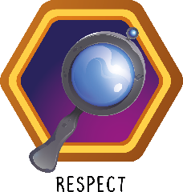  How we talk, listen and value each other | Doesn’t listen to others. | Listens to others. | Actively listens when someone is talking. Summarises what has been said so communication is clear.
 | Doesn’t make time to talk and listen to others when needed. Has to be asked and directed to do this. | Asks if someone has time to talk before starting a sit down conversation. | Always makes time to talk/ listen – if they can’t do it in the moment, makes an arrangement for later and follows this up
 | Doesn’t talk to others, or uses a tone that is rude or patronising. | Speaks to others willingly and politely in a calm tone of voice. | Always shows with tone of voice and body language that the person they are talking to matters.
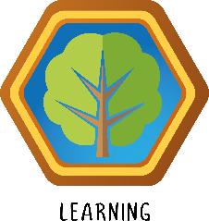  Our approach to our learning and development | Does not put learning into practice, isn’t willing to try something new | Acts on feedback straight away and views it constructively. | Seeks out feedback and sees all feedback as an opportunity for growth
 | Doesn’t think they have anything to learn and doesn’t contribute to their Growth Plan | Engages with their own Growth Plan, identifies things they want to develop further. | Supports others with their growth plans and invites others to see their great practice regularly
 | Not willing to share good practice with others, not recognising the good practice of others | Tells others when they are doing well. Shares good practice with others. | Always striving to improve and develop – researches, reads and self-directs their growth towards excellence
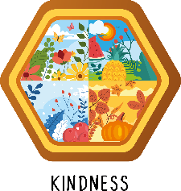  How we make others feel | Talks negatively, complains – mood hoovering | Speaks to everyone on the team every day, knows their names. | Takes time to: thank and praise others; get to know their colleagues and what is important to them
 | Talks down to people, assuming they themselves are right, challenges aggressively, uses sarcasm to make a point | Speaks to everyone clearly, kindly and calmly | Tackles difficult/ sensitive subjects with kindness. Assumes everyone is trying to do a good job.
 | Doesn’t acknowledge people in their space, doesn’t know the names of people who work/ volunteer/ train/ support in their key stage | Makes everyone feel welcome in their space. | Goes out of their way to make positive relationships and make others feel good.

