# **St John Bosco RC Primary School SENDCO Person specification**

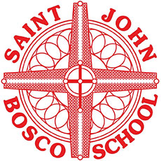

|  |  |
| --- | --- |
| criteria | qualities |
| **Qualifications**  **and training** | * Qualified teacher status * National Award for SEN Co-ordination, or a willingness to complete it within 3 years of appointment (this is a requirement under the SEND Code of Practice) * Degree |
| **Experience** | * Teaching experience * Experience of working at a whole-school level * Involvement in self-evaluation and development planning * Experience of conducting training/leading INSET * Experienced of line managing staff |
| **Skills and knowledge** | * Sound knowledge of the SEND Code of Practice * Understanding of what makes ‘quality first’ teaching, and of effective intervention strategies * Ability to plan and evaluate interventions * Data analysis skills and the ability to use data to inform provision planning * Effective communication and interpersonal skills * Ability to build effective working relationships * Ability to influence and negotiate * Good record-keeping skills |
| **Personal qualities** | * Commitment to carrying out and promoting Catholic values * Commitment to getting the best outcomes for pupils and promoting the ethos and values of the school * Commitment to equal opportunities and securing good outcomes for pupils with SEN or a disability * Ability to work under pressure and prioritise effectively * Commitment to maintaining confidentiality at all times * Commitment to safeguarding and equality |